*Florida International University*

*School of Computing and Information Sciences*

CIS 4911 - Senior Capstone Project

Software Engineering Focus

Feature Document

User Story #624

**Team Member:**

Andrew Mitchell

**Product Owner(s)**:

Francisco R. Ortega

**Mentor(s)**:

Francisco R. Ortega

...

**Instructor**: Masoud Sadjadi

**User Story – Implement Double Tap Gesture**

* As a User I would like to double tap the screen to perform various additional functionality such as pulling up a menu
* Detect Double Tap Gesture

Acceptance Criteria

* Double tap must successfully read.
* Don’t draw on first tap
* Consistent and easy to use.

**Use Case - Double Tap**

Use Case

Be able to double tap the touch screen

Details:

Actor: User

Pre-conditions:

Multitouch must be enabled.

Description:

Use case begins when the user changes double taps the screen. A menu then pops up when it is completed at the location of the tap.

Post-conditions:

Menu must pop up at location of tap.

Decision Support:

Frequency: Very often. As opposed to pulling up an entire UI we can have a ‘branching’ ui we pull up when we double tap.

Criticality: Very High. Implement a fluid UI is core for a good user experience.

Risk: Medium. This is the first multitouch gesture implementation. May cause unforeseen problems.

Reliability: Highly.

Mean time to Failure –  Not often. Some users may experience some inconsistency if they are not accustomed to touch screens.

Availability – Available with touch screen enabled.

Performance:

N/a

Supportability:

Must work with ACER Multitouch.

Modification History:

Owner: Andrew Mitchell

Initiation date: 03/10/2016

Date last modified: 3/10/2016

**Use Case Diagram**

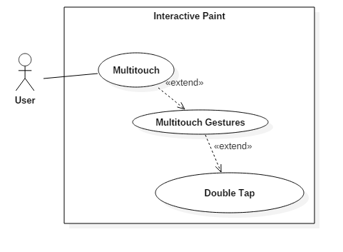

**Sequence Diagram**

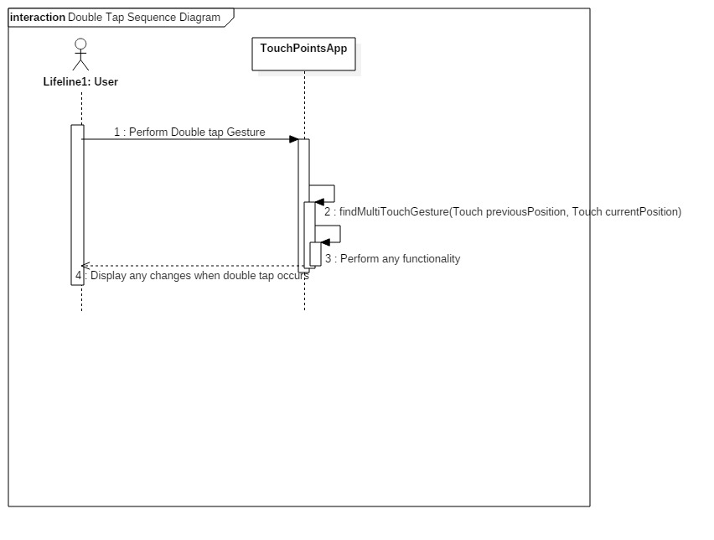

**Class Diagram**

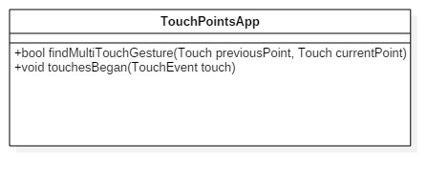

**Unit Test**

Sunny Day :

Tap the screen twice in quick repetition (same finger, same location)

Successfully called up radial menu, no leftover drawing residue.

Rainy Day Tests :

Tap the screen very fast with two fingers, far away from each other

Did not read a ‘double tap’ because they were too far.

No residue

Double tap, then drag finger on second tap

Successfully read the double tap (pulled up radial menu)

Did not ‘draw’ when dragging the second finger.

Sunny Day Tests

Test Case: Pull up radial menu

Test Purpose:

Make sure the double tap works

Test Setup:

1. Tap twice in the same location

Test Output:

A radial menu popped up at the location I tapped.

Expected Output:

A radial menu should pop up where you tapped the multitouch device.

Rainy Day Tests

Test Case: Two far away taps.

Test Purpose:

Make sure the double tap doesn’t happen when you tap far apart.

Test Setup:

1. Tap on the left side of the screen and right side at the same time

Test Output:

Nothing happened.

Expected Output:

Nothing should occur.

Test Case : Double tap and drag

Test Purpose:

Make sure that when you perform a double tap you can’t draw as well.

Test Setup:

1. Perform a double tap, but keep finger down on the second tap.
2. Drag finger

Test Output:

No lines were drawn.

Expected output:

No drawings should occur when you drag your finger after the radial menu popped up.

**Integration Test**

Currently works while drawing is enabled.

This multitouch gesture currently works with the other 2 implemented multitouch gestures of extended touch and two finger tap.

Currently integrated with the enable radial functionality.

**User Guide**

Double tap the screen within 25 pixels and .25 seconds to successfully pull up a radial menu.

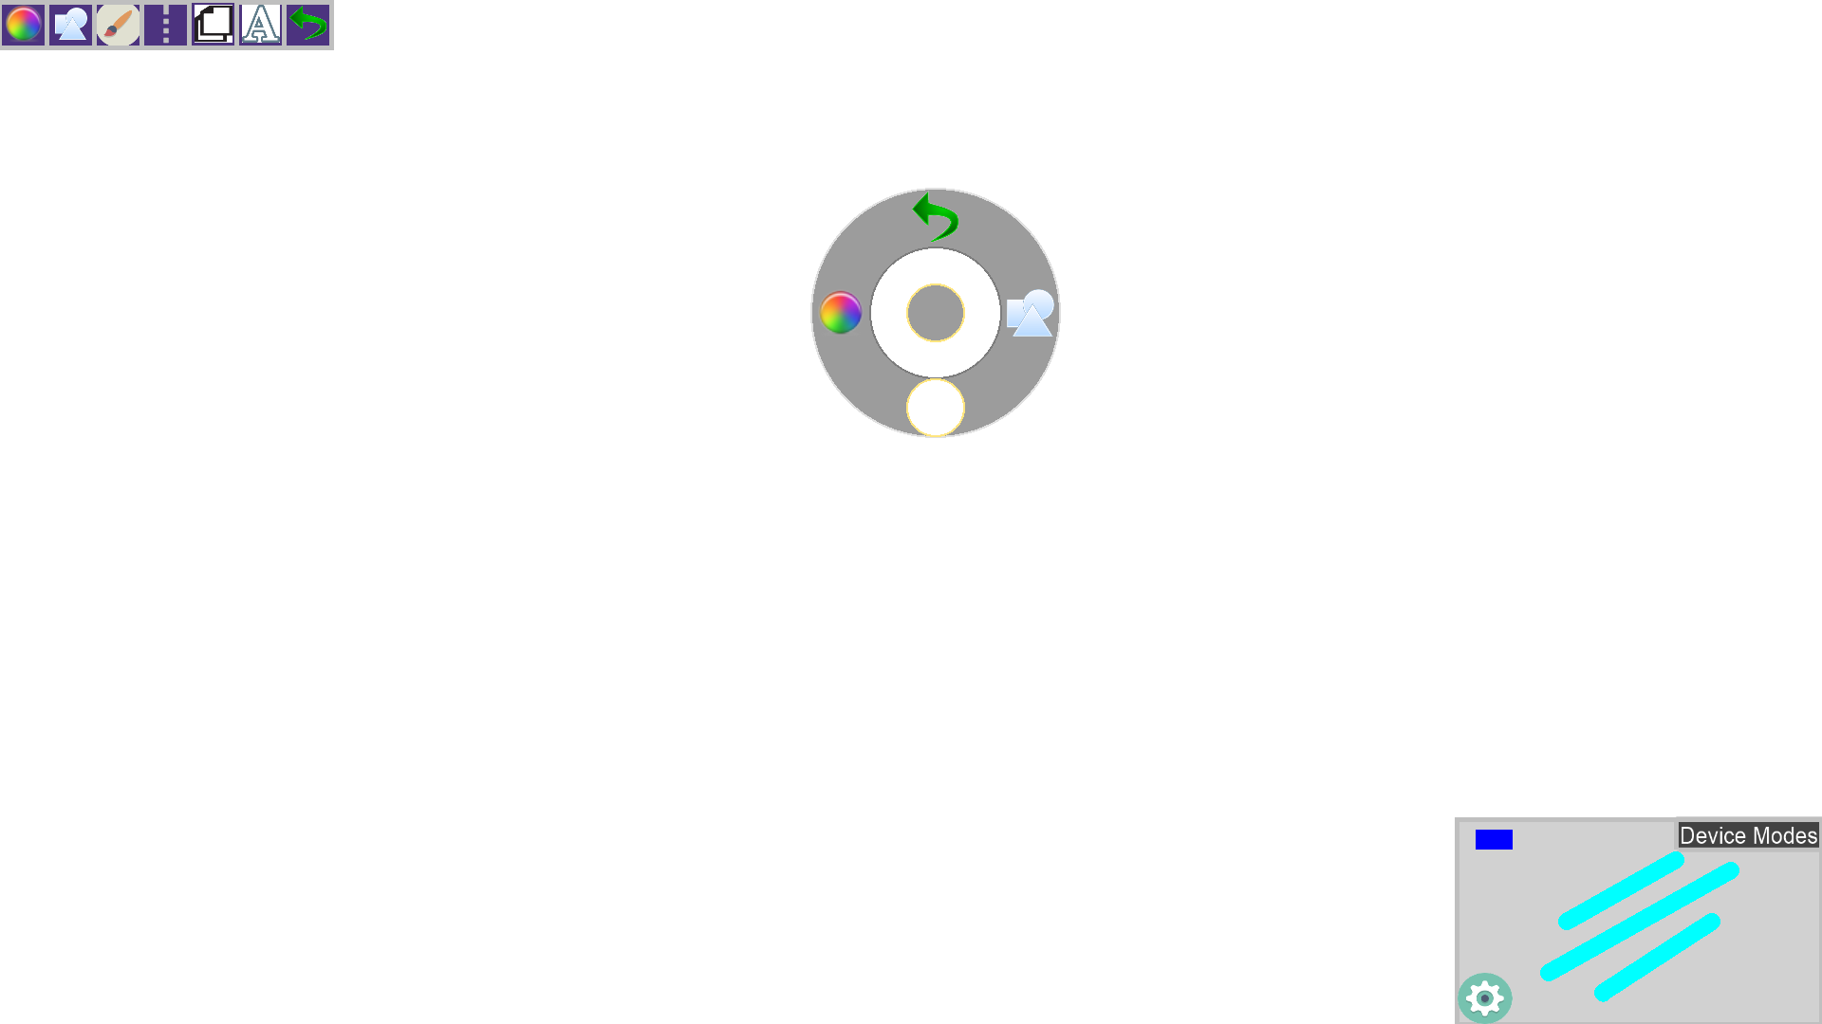

This image shows the current function being called by the double tap. The double tap currently enables the radial menu to show up at the location of the double tap. The top icon will perform an ‘undo’ function, the left will cycle colors, and the right button will change shapes, while the bottom button disables the User Interface.

**Glossary**

Multitouch Gesture – Gesture you perform with fingers or hands on the multitouch screen.

Double Tap – Tap the same location twice within a 25 pixel and .25 second range.